Canadian Lawn Bowls Championships
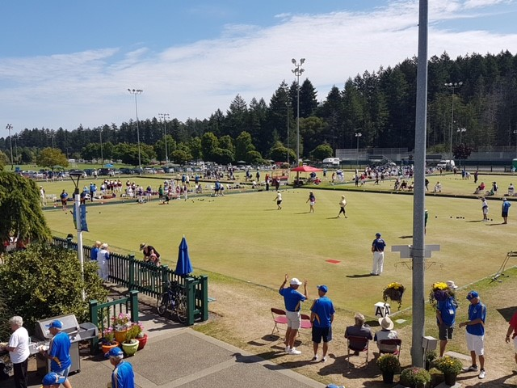
2023 Media Kit

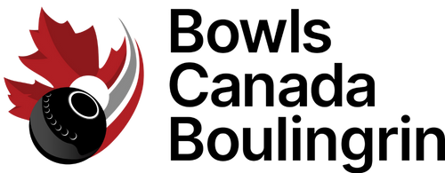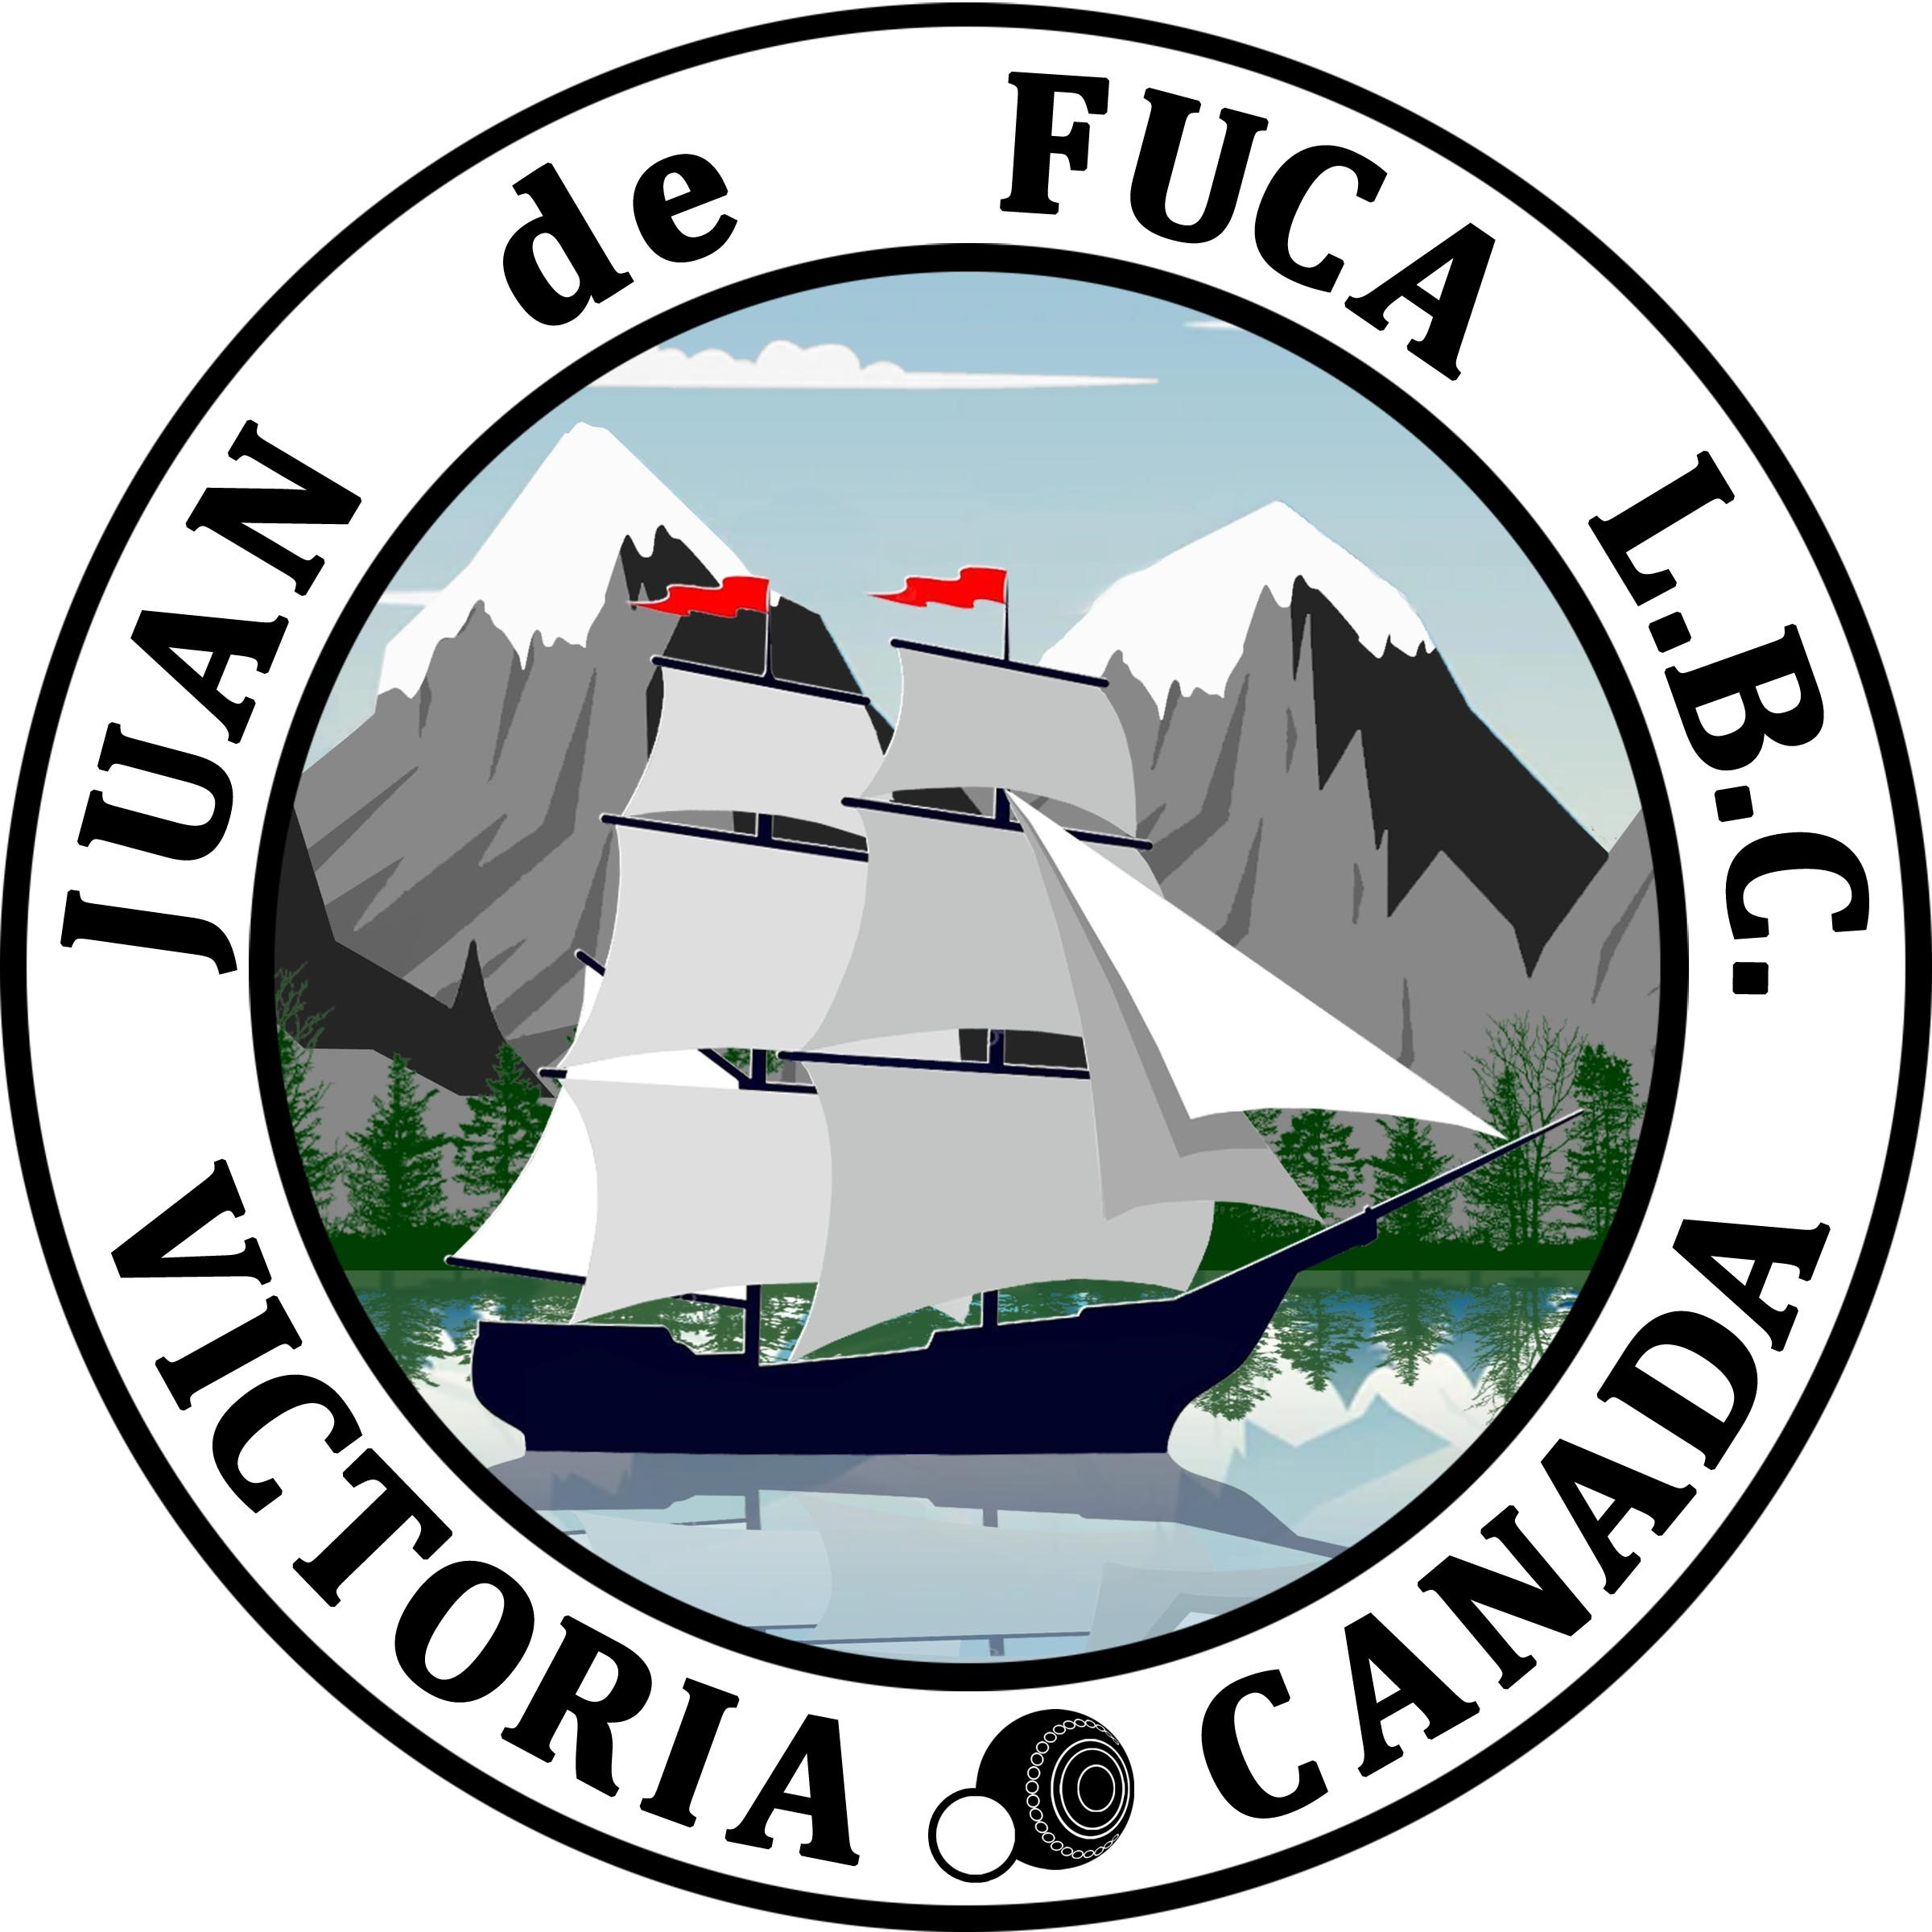

2023 Canadian Championships Set to Begin
The 2023 Canadian Lawn Bowling Championships are set to begin at the Juan de Fuca Lawn Bowls Club in Victoria, BC. The event features men’s and women’s singles from August 18-21, followed by men’s and women’s pairs and fours from August 22-26.

Singles
Defending champion Pat Bird (AB) will be looking to defend his title in a competitive men’s field. Bird will be using this event as a warm-up before heading to Australia for the 2023 World Bowls Champion of Champions event he qualified for by winning the 2022 Canadian Singles title. His path to a 2023 repeat won’t be easy as last year’s bronze medalist Mike McNorton will be eager to climb higher on the podium. 2015 champion John Bjornson will be looking to find his way back to the top, as will 2022 men’s pairs gold medalists Steve Ogden and Stephen Bezanson (NS). With a tough field of 24 men, the finals on August 21st should be quite the show.
There will be a new Women’s Singles champion, as defending champ Jordan Kos (SK) will be in Australia preparing for the 2023 World Championships. Fresh off her Under 18 championship title, Alberta’s Kiera Schaelow will be looking to prove she can play with those over the age of 18 as well. 2022 Singles silver medalist Jan Robinson will be eager to move one step up the podium, although 2014 Singles champion Jean Roney might have something to say about it. With many new faces entering this event, there are plenty of wildcards who could turn the tables in the women’s singles.

Pairs
Elizabeth Cormack and Chrystal Shephard (ON) will be looking to defend their title in Victoria in an almost unrecognizable field: Jennifer MacDonald (AB), Betty Van Walleghem (MB) and Karen Schlotter (SK) are the only returning participants from the 2022 women’s pairs field, all of whom have different partners this time around. Time will tell if the change in players will have an impact on Cormack and Shephard as they look to repeat their win.
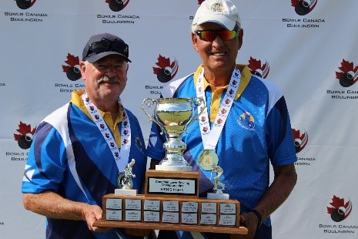
Reigning 2022 champions Steve Ogden and Stephen Bezanson (NS) will be looking to repeat as gold medalists on the men’s side. Standing in their path will be Kin On Lau and Kin Sing Sum (BC) who frequently make an appearance at the nationals. John Devlin and Gilles Cayer (QC) will be making a return visit to the big stage after several years away, as will Mark Bieman and Wayne Hossack (NB). The 10-team field is set, with 8 provinces vying for the title.

Fours
Pat Bird, Francis Standen, Mike O’Reilly and Jon MacDonald (AB) will look to reclaim gold after their 2022 victory in men’s fours. Silver medalists Braeden Campbell, Raymond MacDonald, John Siteman and Liam Campbell (NS) will be eager for revenge, while Saskatchewan’s Jon Pituley will be looking to add to his ever-increasing medal count alongside his father Murray Pituley, and brothers Carter and Brandon Watson.
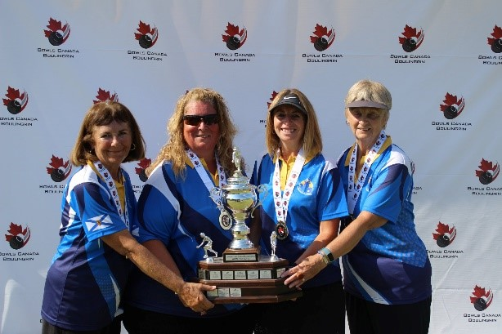
The 2022 women’s fours champions will be returning with a slight modification: Tammy Foster-Veinot, Jackie Foster, and Lorraine Bezanson (NS) have brought along Ann Marie Siteman to replace Debbie Foster. Nova Scotia isn’t the only women’s team to have made a slight adjustment: Ontario’s Cindy Higgins, Manitoba’s Brenda Frank, and Alberta’s Pauline Wong have all swapped out one player from their 2022 squads. While these 4 teams have made some adjustments, the rest of the field will be keen to prove their mettle.
Singles play begins August 19th with the finals on August 21st. Pairs and Fours play begins August 23rd, with the finals wrapping up on August 26th.
For standings and results: https://bowlscanada.com/en/championship/2023-canadian-lawn-bowling-championships/

As the official awards and recognition supplier for BCB, Nothers The Award Store will provide all medals and awards for the event.
For more information, please contact Jake Schuknecht at jschuknecht@bowlscanada.com.

About Bowls Canada Boulingrin
Bowls Canada Boulingrin (BCB) is the governing body responsible for lawn bowls in Canada. The BCB mission is to advance the sport of bowls in Canada. For more details on Bowls Canada Boulingrin and the sport of lawn bowls, visit www.bowlscanada.com.

About Nothers The Award Store
For more than 50 years, Nothers The Award Store has been a supplier of awards and recognition products to Sport Associations, Schools, Professional Associations, Corporate Markets and Service Clubs. Servicing the likes of Western University, Volleyball Canada and Pet Valu to name a few, Nothers has the capacity to service everything from National Championships to local leagues with custom medals and awards, signage and promotional products. The company is Ontario-based and services Canada-wide.

Canadian Championships Fast Facts
August 18-26, 2023
The 2023 Canadian Lawn Bowls Championships will be held at the Juan de Fuca Lawn Bowls Club in Victoria, British Columbia. The 2023 Outdoor Singles will take place from Aug. 19 – 21, while the Fours and Pairs events take place at the Juan de Fuca Lawn Bowls Club from August 22-26, 2023.

Club Information - Juan de Fuca Lawn Bowls Club
1767 Island Hwy Victoria,
British Columbia
Club Contact - 250-478-8384
Website - https://juandefucalbc.ca/
About the Club - Juan de Fuca Lawn Bowls Club celebrated 25 years in 2018. Their four exquisite greens are a legacy from the Commonwealth Games in 1994. They are the only club in British Columbia with four greens.

Championship Information
Championship Dates – Singles – August 19-21, 2023. Fours and Pairs – August 22-26, 2023.
Past Host – Burlington/Kitchener, ON – Burlington LBC & Heritage Greens LBC
Next Host – TBD
Provinces - 9 provinces (ON, BC, SK, AB, MB, QC, NS, NB, PEI)
Participants – 168 total

2022 Champions
Men's Singles | Pat Bird (AB)
Women’s Singles | Jordan Kos (SK)
Men’s Pairs | Steve Ogden and Stephen Bezanson (NS)
Women’s Pairs | Elizabeth Cormack and Chrystal Shepard (ON)
Men’s Fours | Pat Bird, Francis Standen, Mike O’Reilly, and Jon MacDonald (AB).
Women’s Fours | Tammy Foster-Veinot, Jackie Foster, Debbie Foster, and Lorraine Bezanson (NS)

Format of Play
Each province holds provincial playdown tournaments. The winners of these playdowns are awarded a spot on the provincial team.
There is a men’s and women’s division for each event, with pairs and fours consisting of 10 teams, while the Singles consists of 24 athletes of each gender.
Disciplines
Singles: One athlete per team, each athlete rolls 4 bowls. The teams play to 21 points.
Pairs: Two athletes per team, each athlete rolls 3 bowls. The teams play 18 ends.
Fours: Four athletes per team, each athlete rolls 2 bowls. The teams play 16 ends. Each athlete rolls their bowls consecutively before their teammate(s) roll their bowls.
In addition to the individual competitions in each discipline, there is also a provincial competition. This overall competition takes into account the standing points obtained after round robin play. The winner of the men’s and women’s provincial overall trophies are awarded the Cy English Trophy and Lady Alexander Trophy, respectively.

Bowls Explained
Bowls is a strategic, challenging and fun sport that can be enjoyed by anyone. It is played on a large smooth grass surface called a “green”. Lawn bowls are large, hard resin balls with a bias to them, so that they travel along an elliptical path, rather than going straight. The object of the game is to roll your bowls closer to the target than your opponents. The target is a small white ball called a “jack”. The jack is rolled the length of the green to start each end. Players from each team taking turns rolling their bowls down the green toward the jack until all the bowls have been played.

Storylines
The 2023 Canadian Lawn Bowling Championships is the best competition for bowls in Canada demonstrating the high skilled athletes in all age groups. The winners of the Singles event will represent Canada at the 2024 World Bowls Champion of Champions event. Defending champion Pat Bird (AB) will be looking to defend his title in a competitive men’s field; while Jordan Kos (SK) will be in Australia training for World Bowls, leaving an opening for a new Singles champion. Both Women’s Pairs champions, Elizabeth Cormack and Chrystal Shephard (ON), and Men’s Pairs champions, Steve Ogden and Stephen Bezanson (NS) will be returning to defend their 2022 Gold Medals. Lastly, the Men’s Fours 2022 Gold Team, Pat Bird, Francis Standen, Mike O’Reilly, and Jon MacDonald (AB), will have to put up a good fight against teams from Nova Scotia and Saskatchewan. On the other hand, the Women’s Fours will see a lot of movement and changes, as many teams have new and returning members. Nova Scotia’s Tammy Foster-Veinot, Jackie Foster, and Lorraine Bezanson recruited Ann Marie Siteman to help them maintain their championship gold medal.

Useful Links
Bowls Canada
http://www.bowlscanada.com/
Championship page
https://bowlscanada.com/en/championship/2023-canadian-lawn-bowling-championships/
Club Websites
Juan de Fuca Lawn Bowling Club: https://juandefucalbc.ca/
Championship Results
https://bowlscanada.com/en/championship/2023-canadian-lawn-bowling-championships/

Local Media
Newspaper
Victoria Times Colonist
Victoria News
Capital Daily
TV
CTV News Vancouver Island
CBC Victoria
Radio
CFAX 1070
CBCV 90.5

Social Media Pages
Bowls Canada Boulingrin
Facebook
Twitter
Instagram
Youtube

